UKULETHA UMBUSO KANKULUNKULU
EMNDENINI
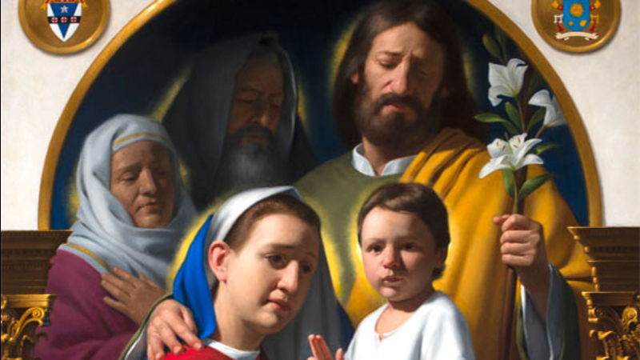
UMKULEKO WOKUZINIKELA
eMndenini oyiNgcwele
Nkosi Jesu, iminyaka yakho ecashile noMame wethu kanye noJosefa oCwebileyo eNazaretha kusikhombisa ubuhle bokuphila impilo yokuhlanganyela nothando okumele umndeni ube yikho. Usifundisa ukubaluleka bokuphilela abanye uzikhohlwe wena, ukulalela ngokuzithoba, ukunikela buthule. Usikhombise ukuzicwebisa unikela uphinde uthole empilweni yondeni nsuku zonke. Namuhla thina malunga waloMndeni wakwa __________________________, kuzwa noma ngubani siveza ukuthi siyakwazi Wena njengeKhanda neNkosi yomndeni wethu. Sizinikela ukuthi umndeni wethu uphile njengoMndeni oyiNgcwele kaJesu, uMaria noJosefa eNazaretha. Sinikela kuwe, iNhliziyo eyiNgcwele cwe kaJesu, ngeNhliziyo kaMaria uMama wakho engenaSici ngokuhlanganyela noJosefa oCwebileyo, umsebenzi wethu, umdlalo wethu, ukudumala kwethu, nezintokozo zethu nesinako okungaphakathi kithina nokungaphandle, kubalwa nezenzo ezinhle zesikhathi esedlule, samanje nekusasa. Lesi isiVumelwano esisenza Nawe, Nkosi. Nkosi Jesu, sicela imbuyiselo yalokho kube ukuthi usivikele, usisize sihlale sethembekile esivumelwaneni sethu nawe, usisize sicwebise izimpilo zethu ngokugcina ngokufanele zonke izibopho zethu siselapha senzele udumo lwakho. Jesu, Nkosi yemindeni woza ubuse phezu koMndeni wethu! Maria, Nkosikazi yemiNdeni, ngena ezinhliziyweni zethu! Josefa oCwebileyo, Mvikeli weMindeni sisize sizinze ekuzindleni ngothando loMndeni oyiNgcwele!

